LIKE (sorting): * for one and more characters / _ for one character

&: Use to substitute a value (enter each time when it runs)

&&: Use the same value of substitute (if entered), not prompt the use each time run

ROUND, TRUNC, MOD, SYSDATE for value not belong to any table must use FROM DUAL;

|  |  |
| --- | --- |
| LOWER(VALUE) = value | INSTR(‘Hello World’, ‘W’) = 6 |
| UPPER (value) = VALUE | LPAD(salary, 10, ‘*’) = *****24000 |
| INITCAP (value)= Value | RPAD(salary, 10, ‘*’) = 24000***** |
| CONCAT(value1. value2) = value1value2 | REPLACE(‘Jack and Jue’, ‘J’, ‘BL’) = Black and Blue |
| SUBSTR(value, 1[3]) = val | TRIM(‘value’ from ‘value123’) = 123 |
| LENGTH(value) = 5 | ROUND(99.93, 2) = 100 |

|  |  |
| --- | --- |
| TRUNC(99.93, 2) = 99 | MOD(1600, 300) = 100 |
| MONTHS_BETWEEN(start_date, end_date) | ADD_MONTHS(‘03-OCT-17, 2) = 03-DEC-17 |
| NEXT_DAY(‘03-OCT-17’, ‘TUESDAY’ = 09-OCT-17 | LAST_DAY (date) = date end of month |
| TO_CHAR(date, ‘fmformat’) | TO_NUMBER(char, ‘fmformat’) |
| TO_DATE(char, ‘fmformat’) |  |

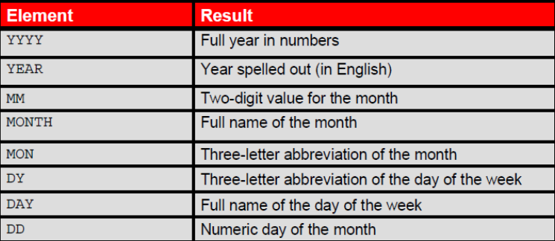





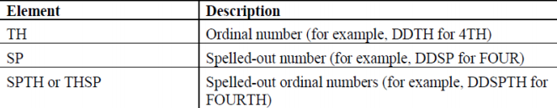

|  |  |
| --- | --- |
| NVL(commission_pct, 0) (if commission_pct is null, proceed to 2nd argument) | NVL2(value, value1, value2) (value1 return if value is not null, value2 return if null) |
| NULLIF(value1,value2) (if value1 = value2, will return NULL, otherwise return value1) | COALESCE(value1, value2,...,valuen) (keep going if th previous are NULL) |
| CASE job_id WHEN ‘IT_PROG’ THEN 1.1*salary ELSE salary | DECODE( job_id, ‘IT_PROG’, 1.1*salary, (else) salary) |

UNF - keep everything

1NF - keep everything, eliminate data that involve calculation

2NF - keep 1NF, eliminate partial dependencies

3NF - keep 2NF, eliminate transitive dependencies